**SLAAC AND DHCP**

**AIM**

To study about SLAAC and DHCP

**THEORY**

**SLAAC** stands for Stateless Address Autoconfiguration, and the name explains what it does. It is a mechanism that enables each host on the network to auto-configure a unique IPv6 address without any device keeping track of which address is assigned to which node.

* **Stateless address assignment** means that **no server keeps track** of what addresses have been assigned and what addresses are still available for an assignment. Also in the stateless assignment scenario, nodes are responsible to resolve any duplicated address conflicts following the logic: Generate an IPv6 address, run the Duplicate Address Detection (DAD), if the address happens to be in use, generate another one and run DAD again, etc.

**PROCEDURE:**

1.START

2.Login into the Cisco Packet Tracer and open a New Window.

3.Drag and Drop Router from the menu bar.

4.Drag and Drop two switches from the menu bar.

5.Drag and Drop the End Devices from the menu bar such as a PC/laptop.

6.Connect all the end devices with the switch .

7.Configure the router for the two switches and the switches also.

8.Set up the Ipv6 address for the End systems connected.

9.Stop

**SLAAC IN CISCO PACKET TRACER**

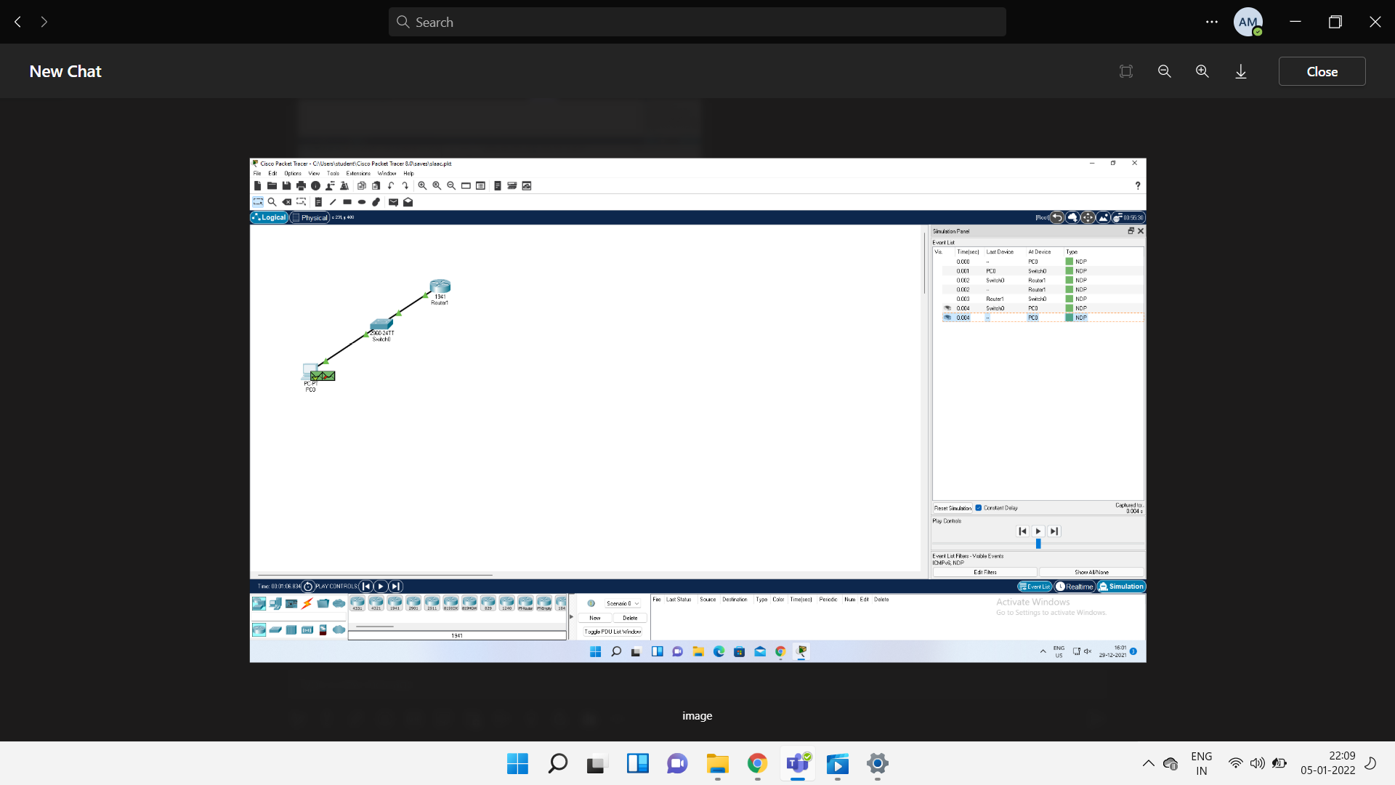

# DYNAMIC HOST CONFIGURATION PROTOCOL

Dynamic Host Configuration Protocol (DHCP) is a network management protocol used to dynamically assign an IP address to nay device, or node, on a network so they can communicate using IP (Internet Protocol). DHCP automates and centrally manages these configurations. There is no need to manually assign IP addresses to new devices. Therefore, there is no requirement for any user configuration to connect to a DHCP based network.

DHCP can be implemented on local networks as well as large enterprise networks. DHCP is the default protocol used by the most routers and networking equipment. DHCP is also called RFC (Request for comments) 2131.

* DHCP manages the provision of all the nodes or devices added or dropped from the network.
* DHCP maintains the unique IP address of the host using a DHCP server.
* It sends a request to the DHCP server whenever a client/node/device, which is configured to work with DHCP, connects to a network. The server acknowledges by providing an IP address to the client/node/device.

DHCP is also used to configure the proper subnet mask, default gateway and DNS server information on the node or device.

There are many versions of DCHP are available for use in IPV4 (Internet Protocol Version 4) and IPV6 (Internet Protocol Version 6).

DHCP runs at the application layer of the TCP/IP protocol stack to dynamically assign IP addresses to DHCP clients/nodes and to allocate TCP/IP configuration information to the DHCP clients. Information includes subnet mask information, default gateway, IP addresses and domain name system addresses.

DHCP is based on client-server protocol in which servers manage a pool of unique IP addresses, as well as information about client configuration parameters, and assign addresses out of those address pools.

## ***Benefits of DHCP***

* Centralized administration of IP configuration
* Dynamic host configuration
* Seamless IP host configuration
* Flexibility and scalability

**PROCEDURE:**

1.Start

2.Login into Cisco Packet Tracer and open a new Window.

3.Drag and Drop a Router from the menu bar.

4.Drag and Drop two Switches from the menu bar.

5.Drag end devices, three laptops and one PC System from the menu bar.

6.Connect the end devices to the switches using a fast ethernet cable .

7.Connect the Switches to the Router using the Fast Ethernet cable.

8.Using the Command line for the Router and configure the router first for the two fast ethernet cable connections.

9. Configure the I P address of end devices and set the configuration to DHCP .

10.DHCP is thus Configured.

11.Stop

**DHCP IN CISCO PACKET TRACER**

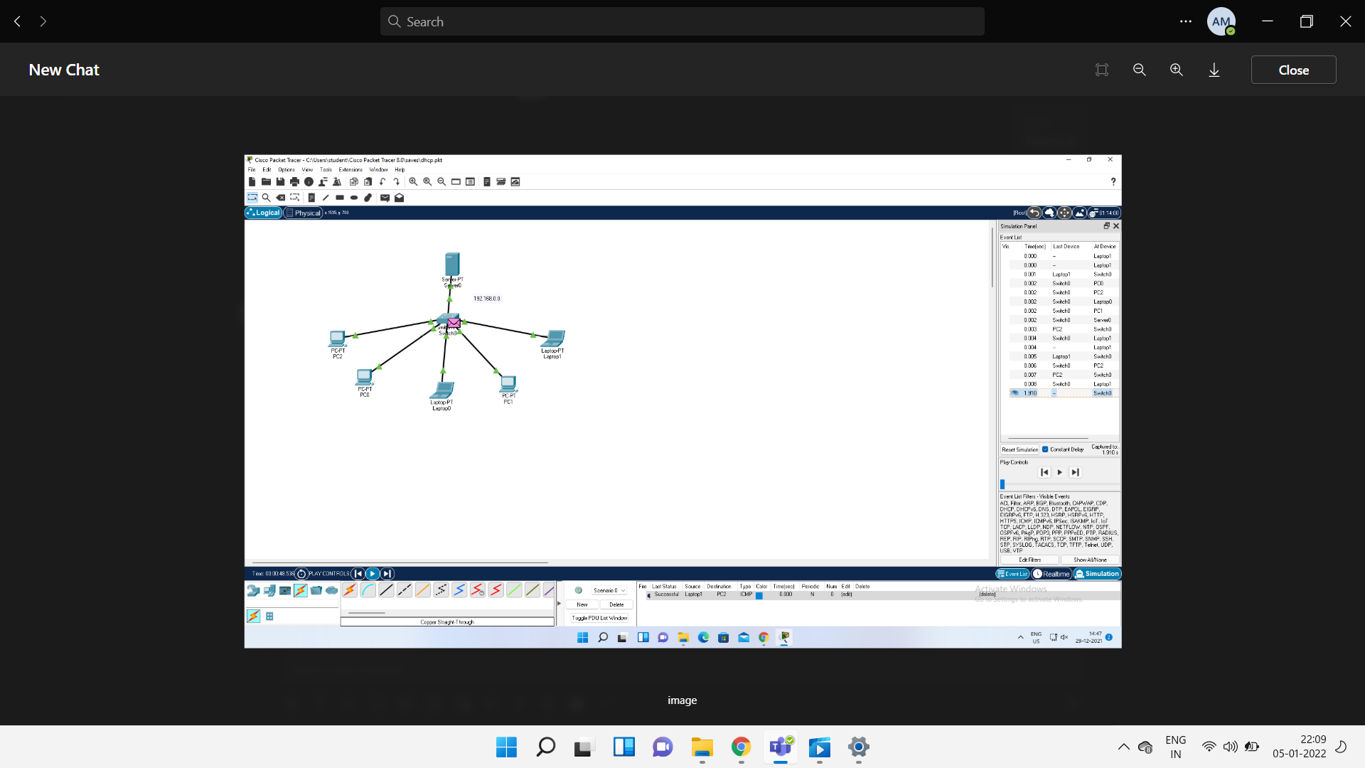

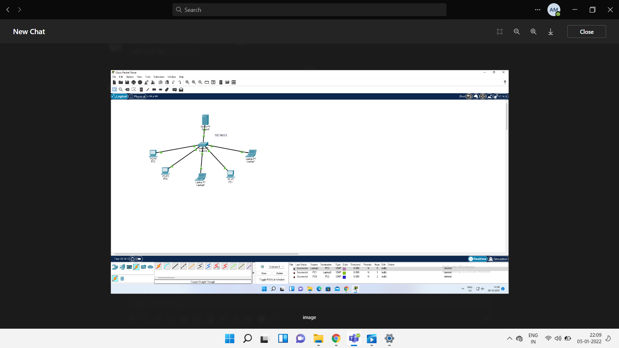

**RESULT**

Hence SLAAC and DHCP is studied, and packets are sent successfully.